# **Data Types in C programming**

Data types is simply used to declared [variables](https://codescracker.com/c/c-variables.htm) or the [functions](https://codescracker.com/c/c-functions.htm). The variable type specifies that how much space it will occupy in the storage and how the bit pattern stored is interpreted. These datatypes have different storage capacities.

C language supports two different type of data types:

1. Primary data types:

These are fundamental data types in C namely integer(int), floating point(float), character(char) and void.

1. Derived data types:

Derived data types are nothing but primary datatypes but a little twisted or grouped together like array, structure, union and pointer.

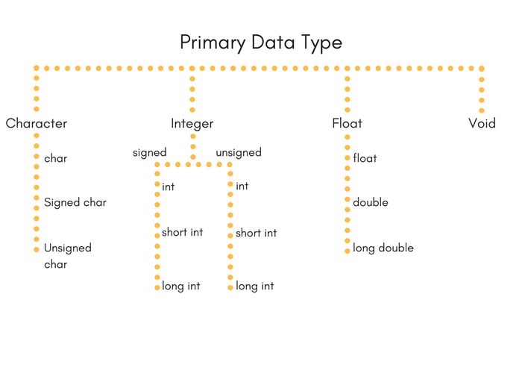

### Integer type

Integers are used to store whole numbers.

Size and range of Integer type on 16-bit machine:

|  |  |  |
| --- | --- | --- |
| Type | Size(bytes) | Range |
| int or signed int | 2 | -32,768 to 32767 |
| unsigned int | 2 | 0 to 65535 |
| short int or signed short int | 1 | -128 to 127 |
| unsigned short int | 1 | 0 to 255 |
| long int or signed long int | 4 | -2,147,483,648 to 2,147,483,647 |
| unsigned long int | 4 | 0 to 4,294,967,295 |

### Floating point type

Floating types are used to store real numbers.

Size and range of Integer type on 16-bit machine

|  |  |  |
| --- | --- | --- |
| Type | Size(bytes) | Range |
| Float | 4 | 3.4E-38 to 3.4E+38 |
| Double | 8 | 1.7E-308 to 1.7E+308 |
| long double | 10 | 3.4E-4932 to 1.1E+4932 |

### Character type

Character types are used to store characters value.

Size and range of Integer type on 16-bit machine

|  |  |  |
| --- | --- | --- |
| Type | Size(bytes) | Range |
| char or signed char | 1 | -128 to 127 |
| unsigned char | 1 | 0 to 255 |

### Void type

Void type means no value. This is usually used to specify the type of functions which returns nothing. We will get acquainted to this datatype as we start learning more advanced topics in C language, like functions, pointers etc.